#include<stdio.h>

#include<conio.h>

#include<string.h>

#include<stdlib.h>

char a[100];

int n, i;

void main()

{

    clrscr();

    printf(“\nenter string”);

    scanf(“%s”,&a);

    n=strlen(a);

    if(a[0]==’a’ && (a[n-1]==’a’ || a[n-1]==’b’) && a[n-2]==’c’)

    {

        for(i=1; i<n-2; i++)

         {

              if(a[i]!=’b’)

               {

                   printf(“\n string is not accepted”);

                   getch();

                   exit(0);

               }

         }

         printf(“\n string is accepted”);

    }

    else

    printf(“\n string is not accepted”);

   getch();

}

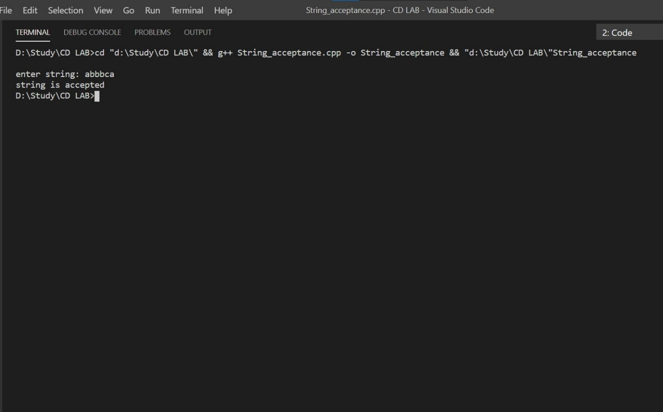***OUTPUT***